Ryan Anderson

Technical Manual

Contents

Requirements specification 2

Detailed design 3

Code listing 4

Completed test log 5

# Requirements specification

A program that can input the original price of an item and the discount and calculate the discounted price. Then display the original price, the discount and the new price to pay.

# Detailed design

Input Output

Item Price Discount

Discount Discounted Price

Original Price

**Begin**

Enter price of item

Enter discount

Display original price

Display discount

Display discounted price

**End**

# Code listing

package item.price;

import java.util.Scanner;

public class ItemPrice {

public static void main(String[] args)

{

float item_price;

float discount_percent;

float discount;

float price_to_pay;

Scanner sc = new Scanner(System.in);

System.out.print(" Item Price? ");

item_price = sc.nextFloat();

System.out.print(" Discount percent? ");

discount_percent = sc.nextFloat();

discount = (item_price * discount_percent) /100;

price_to_pay = item_price - discount;

System.out.println(" The gross price was = " + item_price + " pounds ");

System.out.println(" The discount is = " + discount + " pounds ");

System.out.println(" The price to pay is = " + price_to_pay + " pounds ");

}

}

# Completed test log

|  |  |  |  |  |
| --- | --- | --- | --- | --- |
|  | **Original Item Price** | **Discount** | **Predicted Price** | **Actual Price** |
| **TEST 1** | £100 | 50% | £50 | £50 |
| **TEST 2** | £750 | 35% | £487 | £487.50 |
| **TEST 3** | £1534 | 66% | £521 | £521.56 |

Test 1

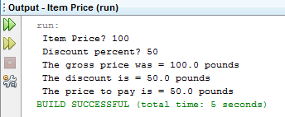

Test 2

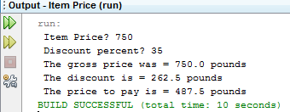

Test 3

